High Resolution Wind Direction Encoder

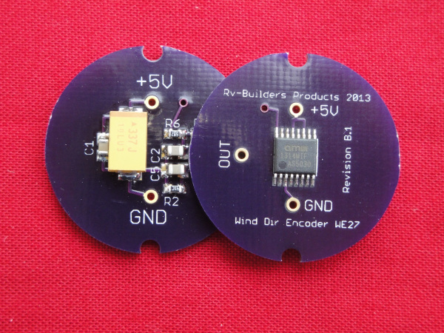

# Description

Based on a quad Hall Effect sensor the device reads the direction of a magnetic field provided by a small diametrically polarized magnet rotating above it. The device provides a linear voltage between 0 and 3.3V coinciding with the absolute angle of the magnet and has no dead band in the full 360 degree swing. With a resolution of 1.4 degree, it provides a 1 degree digital hysteresis for stable readings in a no- wind situation. This is important at the changeover point between 360 and 0 degree to prevent false readings. The sensor, being completely solid state asserts no drag on the vane and has no mechanical parts to ever wear out.

# Applications

* High definition/resolution wind direction monitoring & recording
* Maintenance free
* DIY and custom weather stations

# Features

* Drag free
* Maintenance free, solid state
* No blind spots in full circle
* No false readings due to partially worn potentiometer.
* Interfaces direct to microcontroller ADC inputs
* Built in Hysteresis for jitter free output signal.

# Electrical specifications

* Input voltage nominal 5V, maximum 5.5V
* Desired ADC input impedance > 100K
* DC output impedance ~ 10K
* Current consumption 18 mA @5V

# Connections

|  |  |  |  |  |
| --- | --- | --- | --- | --- |
| Name | Symbol on PCB | Description | Condition | |
|  | | | | |
| Ground | GND | Ground reference | -- | |
| Power | +5V | Regulated power input | 5V +/- 5% , less than 50mv noise | |
| Output Signal | OUT | ~0V to ~3.3V coinciding with angle 0-360 degree | Low <0.1V, | High <3.3>3V |

# Mechanical specifications

* PCB dimension: Rround, 1” diameter
* Sensor to magnet distance 1.5mm +/- 10%

+5V regulated supply

System Ground

Output Signal

0 deg

360 deg.